NONDISCLOSURE AGREEMENT
This Agreement is entered into this 13th day of February, 2006 by and between Jake Litwicki / ThezdinMedia (hereinafter "Recipient") and Aaron V. Bullock, with offices at 6090 Madera Drive, Woodland Hills California, his agents, assignees or successors in interest (“Discloser”).
WHEREAS Discloser possesses certain ideas and information relating to a business enterprise that is confidential and proprietary to Discloser;
WHEREAS Recipient acknowledges that in the course of Recipient’s business relationship with Discloser, Recipient will have access to and become acquainted with information or material that is not generally available to or used by others, or the utility or value of which is not generally known or recognized as standard practice whether or not the underlying details are in the public domain, (hereinafter “Confidential Information,” as further defined in Section 1 below); and
WHEREAS Discloser is aware that Recipient may be now or may in the future perform services or become an employee of others;
WHEREAS Recipient is willing to receive disclosure of the Confidential Information, as defined in Section 1 below, pursuant to the terms of this Agreement in relation to the Engagement;
NOW THEREFORE, in consideration for the mutual undertakings of the Discloser and the Recipient under this Agreement, the parties agree as follows:
- Definition of Confidential Information. “Confidential Information” as employed in this Agreement refers to information or material that is not generally available to or used by others, or the utility or value of which is not generally known or recognized as standard practice whether or not the underlying details are in the public domain, including, without limitation:
  - Information or material that relates to Discloser's “know-how”, operations, plans, processes, purchasing, personnel, sales, customers, finances, accounting, licensing, merchandising, legal strategies, business methods, ideas and practices;
  - Information or material that relates to Discloser’s inventions, technological developments, scientific, technical and other information regarding formulas, patterns, compilations, programs, devices, methods, processes or techniques, software in various stages of development (source code, object code, documentation, diagrams, flow charts), designs, drawings, specifications, models, whether potentially patentable or not, that are owned by Discloser, actually or potentially used in the operation of Discloser's business, or obtained from third parties under an agreement of confidentiality; and
  - Any information of the type described above that Discloser obtained from another party and that Discloser treats as proprietary or designates as confidential, whether or not owned or developed by Discloser.

- Definition of Non-Confidential Information. “Non-Confidential Information” as employed in this Agreement refers to Confidential Information which, through no fault of Recipient’s own, and without breach of this Agreement:
  - Is or has been generally available to the public by any means;
  - Is or has been lawfully disclosed to Recipient by a third party without an obligation of confidentiality being imposed on Recipient; or
  - Is or has been learned by Recipient from a third party without the breach of a confidential relationship with Discloser.

- Definition of Discloser’s Materials. “Discloser’s Materials” as employed in this Agreement includes, without exception, all files, records, documents, plans, drawings, specifications, equipment, software, and similar items, whether maintained in hard copy or in electronic form, relating to Discloser's business, whether prepared or modified by Recipient or others including any copies and other materials in Recipient’s possession, or originating with Discloser, that came into Recipient’s possession.

- No Use or Disclosure; Secrecy Obligations. Recipient agrees to use its best efforts to prevent and protect the Confidential Information, or any part thereof, from disclosure to any person. Recipient agrees to take all steps reasonably necessary to protect the secrecy of the Confidential Information, and to prevent the Confidential Information from falling into the public domain or into the possession of unauthorized persons. Recipient specifically agrees that Recipient will not misuse, misappropriate, or disclose in writing, orally, or by electronic or any other means, any Confidential Information (whether or not conceived, originated, discovered, or developed in whole or in part by Recipient) directly or indirectly, to any other person or use them in any way, either during the term of the Engagement or at any other time thereafter, except as required in connection with Recipient's authorized use of the Confidential Information.

- Term, Termination and Limits of Confidentiality Obligations. The obligations of confidentiality imposed by this Agreement shall continue until (a) the Engagement has terminated and (b) the Confidential Information disclosed to Recipient has become Non-Confidential Information as defined herein.

- Post-Termination. For a period of two years following termination of Recipient’s Engagement with Discloser within a worldwide geographical area (it being understood and agreed that Discloser's industry is worldwide and that Discloser faces competition throughout the world and has customers throughout the world), Recipient agrees not to engage in or contribute Recipient’s knowledge to any work that is then competitive with or similar to the product, process, apparatus or service on which Recipient works or worked or with respect to which Recipient has or had access to Confidential Information while working with Discloser at any time before that termination. However, Recipient will be permitted to engage in such proposed work or activity, and Discloser will furnish Recipient a written consent to that effect, if Recipient furnishes to Discloser clear and convincing written evidence including assurance from Recipient and Recipient’s employer, that the fulfillment of Recipient’s duties in such proposed work or activity will not cause Recipient to disclose, base judgment upon, or use any Confidential Information. The geographical area set forth in this paragraph is divisible so that if this clause is invalid or unenforceable in an included geographical area, that area is severable and this clause remains in effect for the remaining geographical areas in which the clause is valid.

- Transfer of Rights. Recipient agrees that all Confidential Information shall remain the property of Discloser, and that Discloser may use such Confidential Information for any purpose without obligation to Recipient. Nothing contained herein shall be construed as granting or implying any transfer of rights to Recipient in the Confidential Information, or any patents or other intellectual property protecting or relating to the Confidential Information.

- Discloser’s Materials. Recipient agrees that all Discloser’s Materials are and will remain exclusively the property of Discloser and will not be removed from Discloser's premises or, if kept in electronic form, from Discloser's computer systems except with the express prior written consent of Discloser. Recipient agrees to deliver to Discloser promptly on request, or on the date of termination of Recipient’s Engagement, all Discloser’s Materials.

- Unfair Competition. Recipient acknowledge and agrees that the sale or unauthorized use or disclosure in writing, orally, or by electronic or other means, of any of Discloser's Confidential Information obtained by Recipient during the course of the Engagement, including information concerning Discloser's actual or potential work, services, or products, the facts that any such work, services, or products are planned, under consideration, or in production, as well as any descriptions thereof, constitute unfair competition. Recipient promises and agrees not to engage in any unfair competition with Discloser, either during the term of this Agreement or at any other time thereafter.

- Confidential Business Information. Recipient agrees that all of the business information related specifically to Discloser developed by or communicated by or to Recipient in the course of Recipient’s Engagement with Discloser is of a highly confidential nature, and that, unless Recipient has the prior written approval of Discloser, Recipient will not make any use or oral or written disclosure of that information either during or after the term of this Agreement, except that Recipient may disclose that information to persons including the employees of Discloser or its subsidiaries or affiliated companies who may be designated to work with Recipient.

- Secrecy of Agreement. Recipient acknowledges that Discloser regards its mere interest in the subject matter discussed with Recipient to be a matter of strict confidentiality. Recipient therefore agrees that Recipient will not disclose to any third party, at any time, any of the subject matter of this Agreement.

- Attorneys’ Fees. If any legal action is necessary to enforce or interpret the terms of this Agreement, the prevailing party will be entitled to reasonable attorneys' fees, costs, and necessary disbursements in addition to any other relief to which that party may be entitled. This provision will be construed as applicable to the entire contract.

- Entire Agreement. This Agreement represents the entire understanding and agreement of the parties hereto relating to the subject matter hereof and may be modified or waived only by a separate writing executed by Discloser and Recipient expressly so modifying or waiving this Agreement.

- No Waiver. The failure of either party to insist on strict compliance with any of the terms, covenants, or conditions of this Agreement by the other party will not be deemed a waiver of that term, covenant, or condition, nor will any waiver or relinquishment of any right or power at any one time or times be deemed a waiver or relinquishment of that right or power for all or any other times.

- Severability; Amelioratory Amendments. If any provision in this Agreement is held by a court of competent jurisdiction to be unreasonable, invalid, void, or unenforceable, then this Agreement will be deemed amended to provide for the modification of the unreasonable, invalid, void, or unenforceable provision to the extent that the court finds reasonable, and the remaining provisions of this Agreement will continue in full force without being impaired or invalidated in any way.

- Survival of Rights and Obligations. This Agreement shall be binding upon, inure to the benefit of, and be enforceable by (a) Discloser, its successors, and assigns; and (b) Recipient, its successors and assigns.

- Governing Law. This Agreement will be governed by and construed in accordance with the laws of the State of California.

IN WITNESS WHEREOF, the parties have executed this agreement effective as of the date first written above.

Executed on 05/22/06 at Woodland Hills, California.

DISCLOSER
Aaron V. Bullock
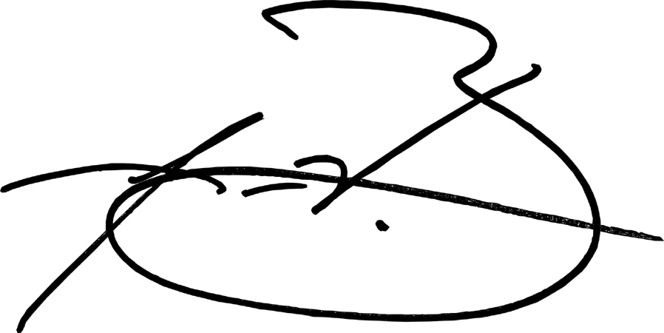 [signature]
Aaron V. Bullock

Executed on _________________ [date] at _________________ [city], California.

RECIPIENT
_________________ [signature]
Jake Litwicki

